ParaBank Automation

1. Project Name: ParaBank Automation
2. Domain: Banking

ParaBank Automation Overview:
This automation project focuses on validating the core functionalities of the ParaBank web application. The automated test cases cover user registration, login, fund transfers between accounts, loan requests, and profile updates. Automation ensures that these critical banking operations function correctly, improves test reliability, reduces manual testing effort, and helps identify defects early in the development cycle.

Objective:
To automate the key functionalities of the ParaBank application—such as registration, login, fund transfer, loan requests, and profile updates

Scope:
- Automation of critical banking functionalities such as:
  - User Registration
  - Login and authentication
  - Fund transfer between accounts
  - Loan request process
  - Profile update
- Verification of application workflows and validation of expected outputs.
- Reduction of manual testing effort and improvement of test reliability.
- Generation of repeatable test cases for regression testing.

Tools & Technologies Used:
- Programming Language: Java
- Automation Framework: Selenium WebDriver
- API Testing: Postman
- Test Management & Execution: TestNG
- Reporting: Extent Reports
- Data Handling: Apache POI (for Excel integration, data-driven testing)
- Build & Dependency Management: Maven (POM)
- Version Control: GitHub
- IDE: (e.g., Eclipse/IntelliJ IDEA)
- Browsers: Chrome, Firefox, Edge

BankingFramework Project Structure

BankingFramework/
│
├── src/
│ ├── main/
│ │ ├── java/
│ │ │ ├── drivers/ # WebDriver related classes
│ │ │ │ ├── DriverFactory.java
│ │ │ │ └── DriverManager.java
│ │ │ │
│ │ │ ├── pages/ # Page Object classes
│ │ │ │ ├── BasePage.java
│ │ │ │ ├── HomePage.java
│ │ │ │ ├── RegisterPage.java
│ │ │ │ ├── TransferPage.java
│ │ │ │ ├── LoanRequestPage.java
│ │ │ │ ├── UpdateProfilePage.java
│ │ │ │ ├── OpenAcc.java
│ │ │ │ ├── OverViewPage.java
│ │ │ │ └── UserDetails.java
│ │ │ │
│ │ │ └── utils/ # Utility/helper classes
│ │ │ └── (utility classes)
│ │ │
│ │ └── resources/ # Config and log files
│ │ ├── config.properties
│ │ └── log4j2.xml
│ │
│ └── test/
│ ├── java/
│ │ ├── tests/ # Test classes
│ │ │ ├── BaseTest.java
│ │ │ ├── TC_01_Verify_New_User_Registration.java
│ │ │ ├── TC_02_VerifyLoginFunctionality.java
│ │ │ ├── TC_03_Verify_Fund_Transfer_Between_Accounts.java
│ │ │ ├── TC_04_Verify_Loan_Request.java
│ │ │ └── TC_05_Verify_Profile_Update.java
│ │ │
│ │ ├── dataProviders/ # Data provider classes for data-driven testing
│ │ │ └── DataProviders.java
│ │ │
│ │ └── listeners/ # TestNG listeners for reporting/logging
│ │ └── TestListeners.java
│ │
│ └── resources/ # Test resources
│ ├── testData/ # Test data files (Excel, JSON, etc.)
│ │ └── (data files)
│ ├── crossBrowser.xml # Cross-browser TestNG suite
│ └── testng.xml # Main TestNG suite
│
├── logs/ # Log files generated during execution
├── test-output/ # TestNG reports output
├── target/ # Maven build output
├── pom.xml # Maven project file
└── README.md # Project overview and instructions

Folder Structure Explanation
- src/main/java – Main application code
  - drivers/ – Manages WebDriver setup and browser handling.
    - DriverFactory.java → Creates WebDriver instances.
    - DriverManager.java → Manages driver lifecycle.
  - pages/ – Page Object classes representing UI pages.
Example: HomePage.java, RegisterPage.java, TransferPage.java.
  - utils/ – Utility/helper classes (e.g., Excel reader, wait methods).
- src/main/resources – Configuration files
  - config.properties → Environment setup (URL, browser, credentials).
  - log4j2.xml → Logging configuration.
- src/test/java – Test-related code
  - tests/ – TestNG test classes implementing test scenarios.
Example: TC_01_Verify_New_User_Registration.java.
  - dataProviders/ – Classes providing data for data-driven testing.
Example: DataProviders.java.
  - listeners/ – TestNG listeners for enhanced reporting/logging.
Example: TestListeners.java.
- src/test/resources – Test resources
  - testData/ → Excel, JSON, or other test data files.
  - crossBrowser.xml → TestNG suite for cross-browser execution.
  - testng.xml → Main TestNG suite file.
- logs/ – Execution logs generated by Log4j.
- test-output/ – TestNG generated reports.
- target/ – Maven build output (compiled code, JARs).
- pom.xml – Maven configuration file (dependencies, plugins).
- README.md – Project documentation and instructions.

TestCases

TC ID | Module | Scenario | Test Case Name | Status
TC_01 | User Registration | Register new user successfully | Register Account Successfully | Pass
TC_02 | Login | Verify valid login | Verify Login Functionality | Pass
TC_03 | Fund Transfer | Transfer funds between accounts | Verify Fund Transfer Between Accounts | Pass
TC_04 | Loan Request | Apply for a loan | Verify Loan Request | Pass
TC_05 | Profile Update | Update phone number | Verify Profile Update | Pass

Test Data
- The DataProviders class centralizes all test data for the ParaBank automated tests, enabling data-driven testing.
- register DataProvider reads user registration data from the Excel file at src\test\resources\testData\Registration.xlsx, sheet "register".
- Each row represents one test case.
- Data is read into a Map<String, String> with keys as column headers (First Name, Last Name, Address, City, State, Zip, Phone, SSN, Username, Password, Confirm Password).
- This allows the registration test method to dynamically access test data.
- transferData DataProvider provides inline test data for fund transfer tests, including Username, Password, Account Type, and Transfer Amount.
- loanRequestData DataProvider provides inline test data for loan request tests, including Username, Password, Loan Amount, Down Payment, and Account Index.
- updateProfileData DataProvider provides inline test data for profile update tests, including Username, Password, and Updated Phone Number.
- These DataProviders allow TestNG to automatically supply data to test methods, enabling tests to run multiple times with different input sets without changing the test code.
- They verify key functionalities: registration, login, fund transfer, loan request, and profile updates efficiently and consistently.
Approached: The approach uses Apache POI, a Java library, to read test data from Excel files, enabling data-driven testing by providing dynamic input to test methods.
Test Reporting and Logging
- TestNG Reports: Provides default execution results and pass/fail status.
- Extent Reports: Generates detailed, interactive HTML reports with test steps and logs.
- Logger: Captures real-time execution logs for each test step.
- Screenshots: Captured on failures or critical steps for visual verification.

Console output
1. Go to project directory:
cd "D:\Growskills\Automation testing\BankingFramework"
D:
2. Run all tests
mvn clean test
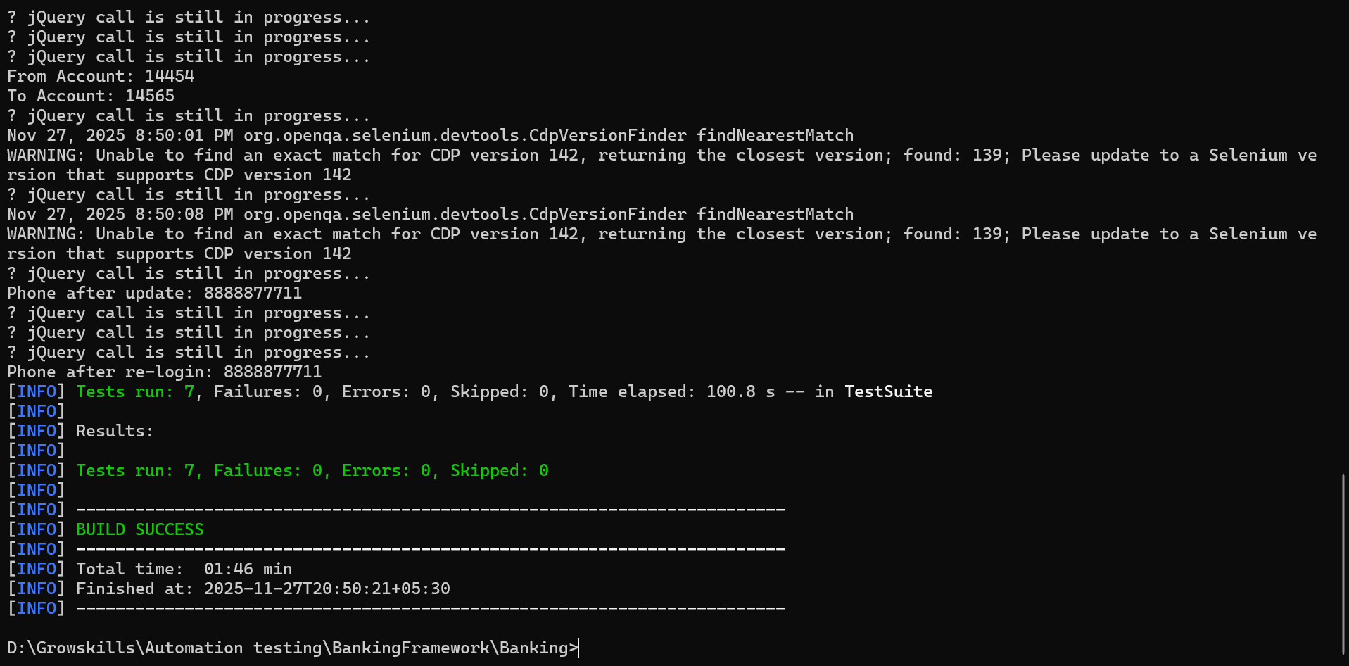

Log
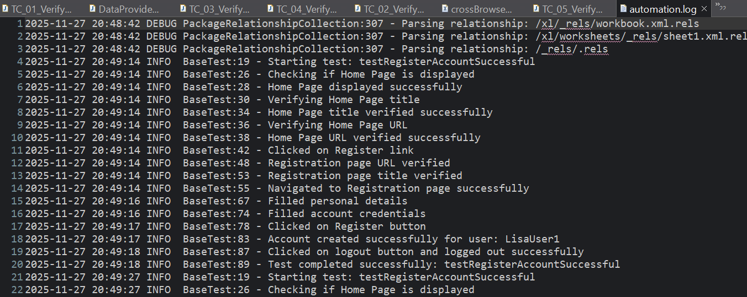
Report

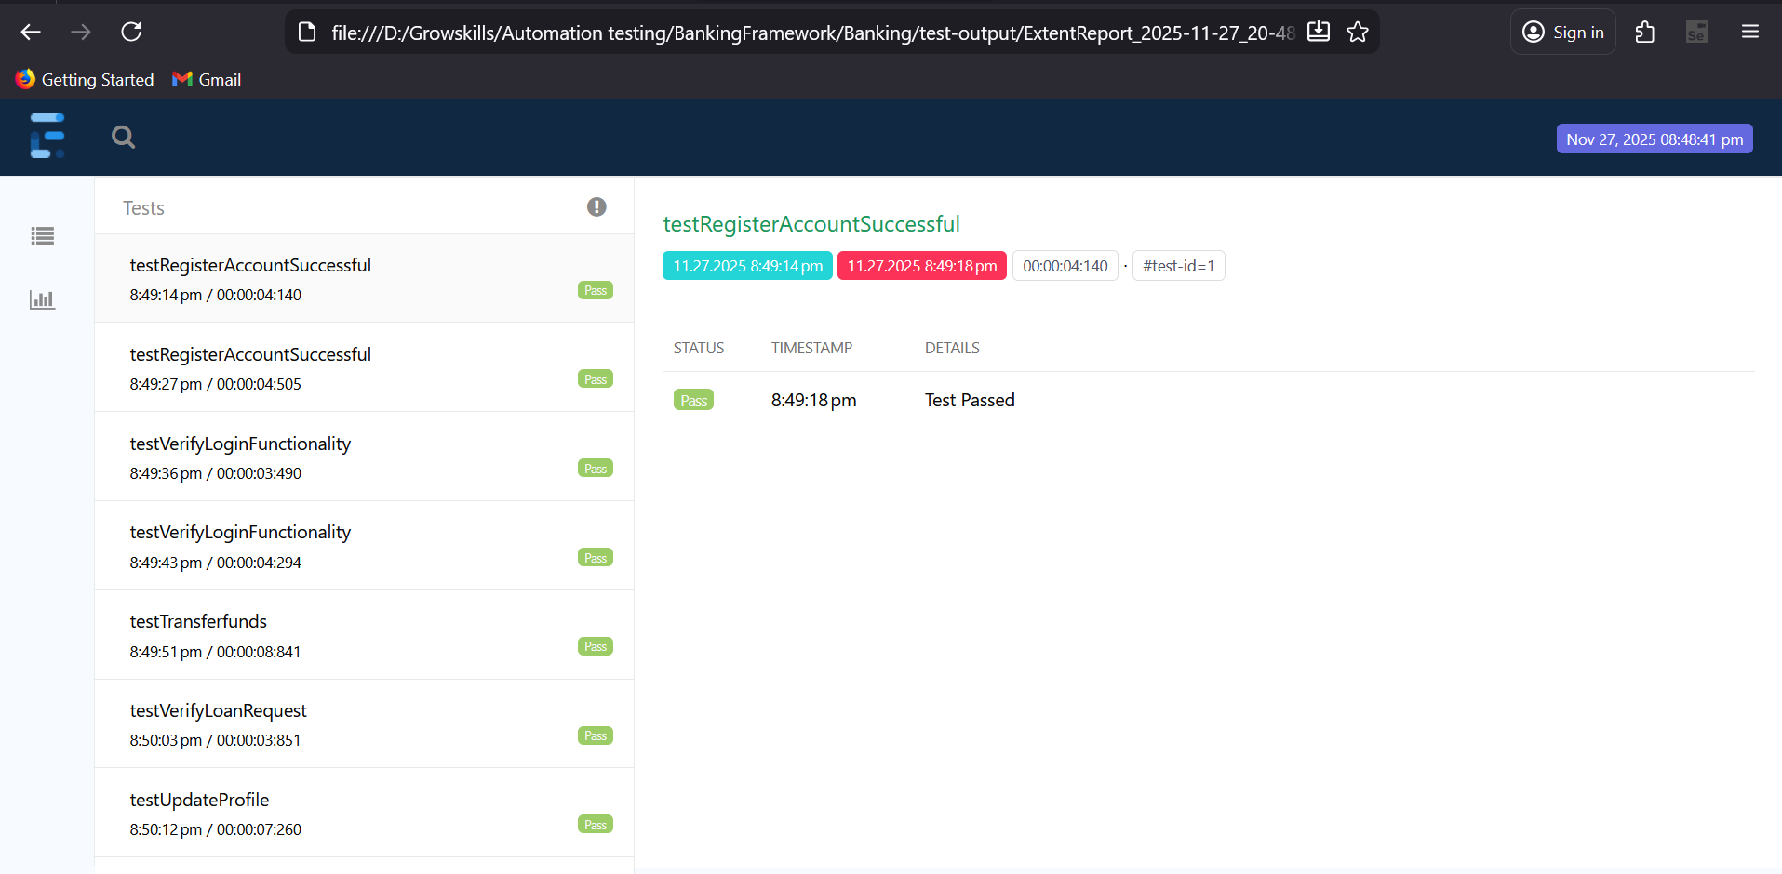

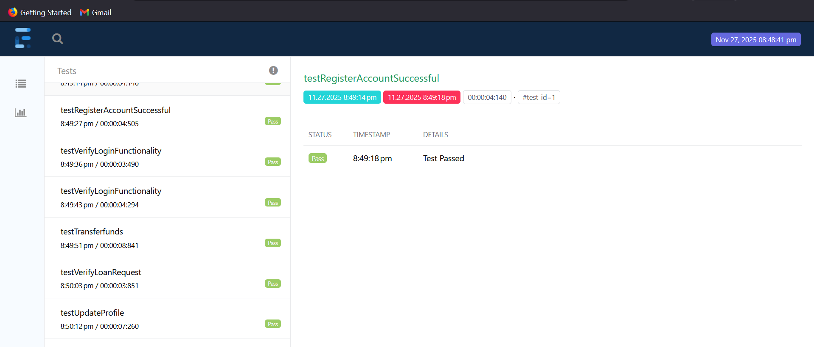
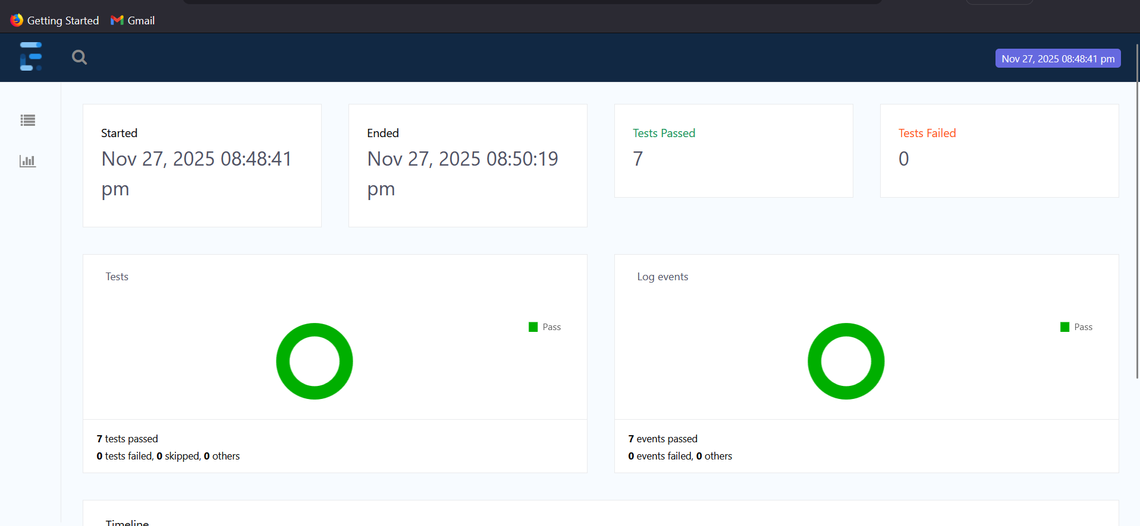

Challenges & Solutions
- Dynamic Elements – Used stable locators + explicit waits.
- Synchronization – Added WebDriverWait, FluentWait, jQuery AJAX wait.
- Browser Compatibility – Used WebDriverManager + browser factory.
- Test Data Management – Externalized data using Excel/POI + DataProvider.

Conclusion
The framework effectively handles dynamic elements, synchronization, cross-browser execution, and test data management, making it stable and reliable. Through this project, I learned how to design a scalable automation framework, work with waits and AJAX handling, manage test data using external files, and implement cross-browser testing using WebDriverManager and TestNG.

API TESTING - POSTMAN

Overview
API testing was performed on the ParaBank Customer Details endpoint using Postman. The objective was to validate correct responses for valid customer IDs and ensure proper error handling for invalid inputs. Tests included status code validation, response time checks, field verification, and JSON schema validation.

Test Cases
TC ID | Test Category | Test Case | Input | Expected Result
TC01 | Positive | Get Customer Details – Valid | Valid customerId | 200 OK, response < 2000ms, JSON fields correct, schema valid
TC02 | Negative | Invalid ID (0) | customerId = 0 | 4xx error
TC03 | Negative | Invalid ID (-1) | customerId = -1 | 4xx error
TC04 | Negative | Invalid ID (abc) | customerId = abc | 4xx error
TC05 | Negative | Invalid ID (!@#) | customerId = special characters | 4xx error
TC06 | Negative | Non-existing ID | customerId= 99999999 | Not Found / Customer does not exist

Environment & Collection Setup
To make the API testing reusable and maintainable, an environment named ParabankTest was created in Postman. This environment stores all frequently used variable values so tests can run dynamically without manually updating each request.
1. Environment Variables
Variable Name | Purpose
base_url | Stores the ParaBank API base URL to avoid repeating it in every request.
customerId | Stores a valid customer ID for positive testing.
customerIdInvalid1 | Invalid ID = 0 (negative test).
customerIdInvalid2 | Invalid ID = –1 (negative test).
customerIdInvalid3 | Invalid ID = "abc" (negative test).
customerIdInvalid4 | Invalid ID = 999999999 (non-existing ID).
invalidIdList | Array of invalid IDs used for loop-based negative testing.
invalidIds | Duplicate list used for data-driven negative testing.

2. Create a collection inside the workspace with “ParaBank_API”

Request
1. Get Customer Details – Valid
- Method: GET
- URL: https://parabank.parasoft.com/parabank/services/bank/customers/12212
- Request Headers:
  - Accept: application/json
- Description: Fetches the details of a customer with a valid customer ID.

2. Get Customer Details – Invalid
- Method: GET
- URL: https://parabank.parasoft.com/parabank/services/bank/customers/1
- Request Headers:
  - Accept: application/json
- Description: Attempts to fetch details of a non-existent customer; should return a 4xx error.

3. Get Customer Account Details
- Method: GET
- URL: https://parabank.parasoft.com/parabank/services/bank/customers/12212/accounts
- Request Headers:
  - Accept: application/json
- Description: Retrieves all accounts associated with a given customer ID.

4. Get List of Transactions for an Account
- Method: GET
- URL: https://parabank.parasoft.com/parabank/services/bank/accounts/12345/transactions
- Request Headers:
  - Accept: application/json
- Description: Retrieves all transactions for the specified account.

5. Filter Transactions by Amount
- Method: GET
- URL: https://parabank.parasoft.com/parabank/services/bank/accounts/12345/transactions/amount/300
- Request Headers:
  - Accept: application/json
- Description: Fetches transactions for an account filtered by a specific amount.

6. Transfer Funds
- Method: POST
- URL: https://parabank.parasoft.com/parabank/services/bank/transfer
- Query Parameters:
  - fromAccountId=13344
  - toAccountId=12456
  - amount=100
- Request Headers:
  - Accept: application/json
- Description: Transfers funds from one account to another.

7. Withdraw Funds
- Method: POST
- URL: https://parabank.parasoft.com/parabank/services/bank/withdraw
- Query Parameters:
  - accountId=13344
  - amount=100
- Request Headers:
  - Accept: application/json
- Description: Withdraws funds from a specified account.

8. Create a New Account
- Method: POST
- URL: https://parabank.parasoft.com/parabank/services/bank/createAccount
- Query Parameters:
  - customerId=12212
  - newAccountType=1
  - fromAccountId=12456
- Request Headers:
  - Accept: application/json
- Description: Creates a new account for a customer, optionally transferring funds from an existing account.

Key Validations Performed
- Status Code Verification
- Response Time Check
- JSON Header (Content-Type) Validation
- Response Field Validation
- JSON Schema Validation
- Positive + Negative Testing using Dynamic Data

Commands
1. Exporting a Postman Collection JSON
2. Exporting a Postman Environment Collection JSON
3. Generate HTML or other reports
newman run "ParaBank _API.postman_collection.json" -e "ParabankTest.postman_environment.json" -r htmlextra --reporter-htmlextra-export "ParaBank_Report.html"

Report

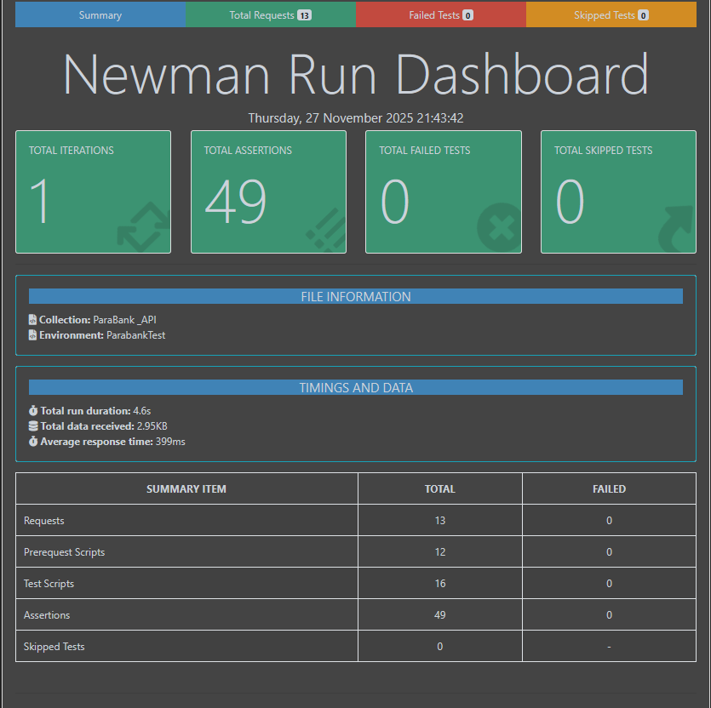

Conclusion
API testing ensured that the ParaBank Customer endpoint correctly handled both valid and invalid inputs. Through schema validation, field verification, and negative testing, the API was confirmed to be stable, reliable, and consistent in its response handling.

Github: https://github.com/AnaghaAni/ParaBanking.git

